Space Planning

Problem:
Trying to adjust a product that has 2 height, and it won’t adjust it

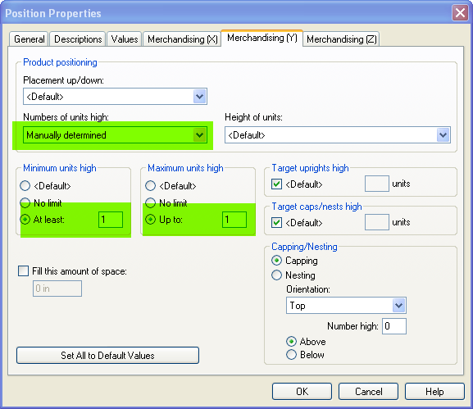 | Double click the product  Go to the product properties  Click Merchandising Y tab  Numbers of unit High  Manually determined  Minimum units high  At Least 1  Maximum units high  Up To 1

